**SMART TRAP**

**Design Review 3**

**Team Members:**

* **Team Leader:** Kirk Nelson
* **Team Treasurer**: Naif Almutairi
* **Sponsor contactor:** Yanlin Zhang
* **schedule Coordinator:** Zaid Aldashti

**Client:**

* Dr. Crystal M. Hepp
* Email: [Crystal.Hepp@nau.edu](mailto:Crystal.Hepp@nau.edu)
* Phone: 928-523-7406
* Office: 90-215

**GTA:**

* Ashwija Korenda
* Email: [AshwijaKorenda@nau.edu](mailto:AshwijaKorenda@nau.edu)

**Table of Contents:** **Page Number:**

1. Introduction 3
2. WBS chart 3
3. Subsystem 1 4
4. Subsystem 2 5
5. Subsystem 3 6
6. Subsystem 4 7
7. Conclusion 8

**Introduction**

We are SMART Mosquito Trap Team 2 and are project is focused on creating a mosquito trap. In combination with team 1, our goal is to design, build, and test a mosquito trap that will, attract, catch, and dehydrate mosquitos. These mosquitos will be used for research being done by Dr. Crystal M. Hepp. Dr. Hepp is an ecologist working in the SICCS building. Four our teams part, we have been tasked with designing, building, and testing a system that will use the sun's energy to power the mosquito trap. Using an open source example online, we have designed a solar charger. This charger will use a solar panel to convert the energy form the sun to provide power to the trap and to charge a backup battery. The backup battery will be used to supply power when the solar panel no longer offers enough power to the trap. As mentioned earlier, we have 3 phases for this semester: The design phase, building phase, and testing phase. This will gone over in more detail below. We are currently in the building phase and if all goes well, the testing phase will soon follow.

**WBS Chart:**

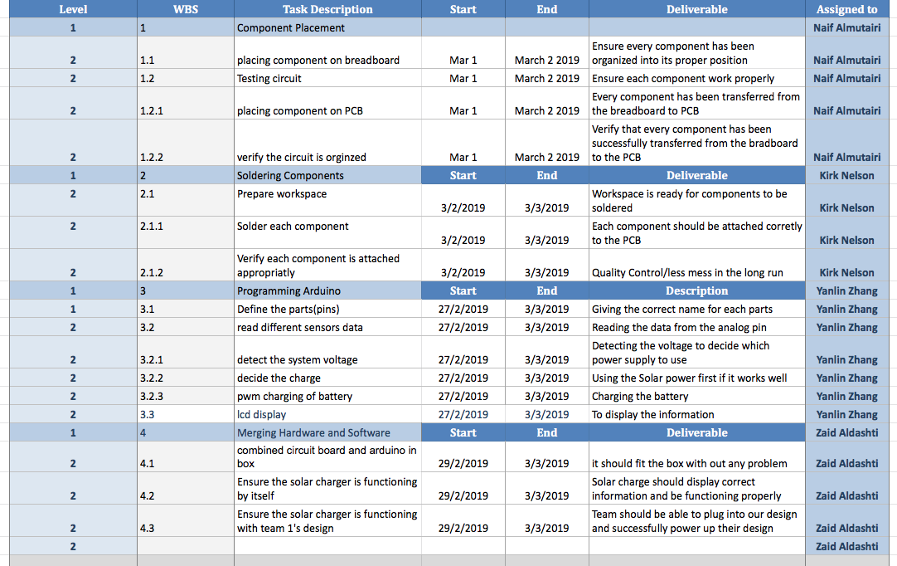

Above is our groups Gantt chart. We as a group work together on all the assignments and tasks related to the project. Since we are currently in the building phase, we based our Gantt chart on this phase. We then broke the building phase up into 4 different parts. Each one of us is responsible for being the leader and responsible for their part. These parts or subsystems will be discussed into further detail below.

**Subsystem 1 : Component Placement**



I'm Naif who will work on the component placement, first thing in my part that I will work on is building phase it will be the first components that I will finish in our project, the major focus in our project is that we ensure every component has organized into its proper position by placing each component on a breadboard, which that will be the first section that I had worked on, all the component placement took us probably around two days to finish it. The second step is will be testing the circuit to ensure each component works properly and determine the circuit whether the component is working properly. Third thing in our component placement is placing component on PCB and this part which was the more hardest part between the other component because I should make sure that every component has been transferred from the breadboard to PCB, its very sensitive part in our project like if I missed up with small thing, the whole parts will get messed up. The most challenging and risky thing is verifying the circuit is organized, because all our other parts depend on the component placement so it’s should be really perfect and organized to complete our project in the right way. Verification of the circuit is to verify that every component has successfully transferred from the breadboard to the PCB, this is determined by testing the circuit which will act as a confirmation. In the building phase, the real operation of the device was determined by placing the required component in the breadboard, if anything wrong happen in my parts we all will not be happy, but I’m very sure that everything will be perfect. My part is really the riskiest section because it's the main portion in our project, all the other subsystem depends on my part. So I should make sure everything in the component should be highly organized. The main challenge that I face in my component placement is I should make sure every component organized into its proper position.

**Subsystem 2: Soldering Components to PCB:**

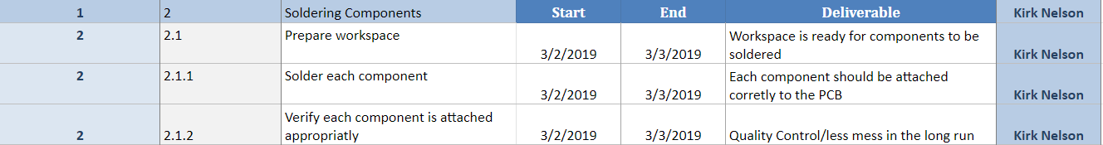

For this task, the objective is to solder all of the components Naif placed onto the board. Soldering these components is crucial and if it's not done properly, will compromise the success of the project. This portion is completely dependent on how well and accurately Naif did his part. This first step is preparing the workspace. Making sure the workspace is clear and has everything that will be needed to solder makes the process go much smoother. The workspace will need to be clear of debris and anything that doesn't belong there. Then the soldering iron will need to be turned along with the ventilator. The deliverable for this portion will be that the workspace is appropriately prepped and ready for components to be soldered. The next step is to start soldering the components. It is important that we solder each component one at a time. This ensures that each component is properly connected to the board. The deliverable for this will be that each component is properly connected to the board. The next step is to verify each component has been attached correctly. After each component is soldered, we will check the component and make sure there is nothing wrong about the connection. The deliverable for this will be that quality control. Taking the time to be teadius and check each part individually ensures that the overall quality of each connection is the best it can be. It also creates less mess in the long run. By doing it sooner rather than later, creates less confusion later on down the road if something isn't working. We can find a specific problem and address it appropriately. There is also a start and finish date on the Gantt chart. The dates above suggest that this will be done before spring break. This date does depend on Naif’s part and also depends on when the rest of our parts show up.

**Subsystem 3: Preparing Arduino**

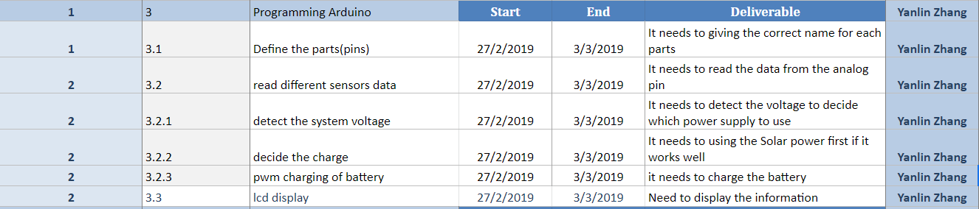

I am Yanlin who will finish the programming via Arduino. The programming aims to choose the Solar power as priority cause our team is working on power supply.As WBS shown above, I have finished this part at last sunday since this part is separate from other parts. For this part,at first, we are supposed to define each parts to match the ports in PCB. We want to use port to control the power supply. As a result, it is important to match the each variance with correspond port. Then, we will design several subsystems to achieve each function like reading the sensors data and detecting the system voltage. For reading the different sensors data, we use the program sentence like If else. For instance, if it can read the sensors data,it will continue work to next subsystem. Otherwise, it will rework this subsystem. If it has reworked 100 times, it will automatically jump to the subsystem which choose the emergency power bank as power supply. After reading different sensors data, it will work on next subsystem which is detecting the system voltage. This subsystem is one of the most important part in our whole project because we want to use the current voltage to choose the power supply. I define a standard voltage as 12V right now since I do not know which voltage output Team #1 want to use. For example, if the system voltage is lower than 12 V, it means the Solar power can not supply enough power for the whole device. As a result, it will

automatically jump to the subsystem which choose the emergency power bank as power supply. After detecting the correct system voltage, the system will choose the solar power as power supply.This part is called decide the charge. After deciding the solar power as charge method, we also want to achieve the solar power charge the emergence power bank at same time. Thus, I design another subsystem which is charging the battery. Therefore,we can make sure power bank have enough energy all the time. The last subsystem is ICD display which means all the information you can see in the screen.

Since I have finished the programming, I am waiting for getting all the parts we ordered in order to design the PCB. At last, we are supposed to program the code into the PCB so that we can achieve the function we designed. If the parts did not arrive on time, I will help other members to finish their part.

**Subsystem 4: Merging hardware and software**

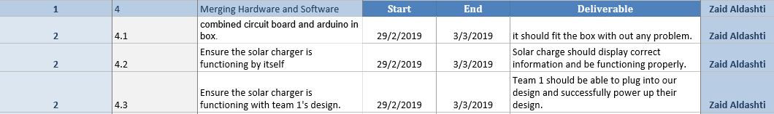

In this task, I will talk about merging Hardware and software. First of all, I am Zaid and my client is Dr. Crystal Hepp. The Hardware represent the circuit board and the software represent the Arduino so after naif and kirk complete the circuit board by soldering it and placing the component and Yanlin complete the Arduino by programming it I will merge the hardware and software which I will combine the circuit board and Arduino in one box and the deliverable for this step is the Arduino and circuit board should fit in the box without any problems. The second point is Ensure the solar charging that functioning by itself so after I combined the circuit and Arduino in one box I will test the solar charger in our design project and the deliverable for the second point is solar charger should display correct information and work without any problems. After I test the solar charger in our team design project I will take the solar charger and test it with team 1s design to make sure that the whole project will work without any problems and the deliverable for this point is team 1 should be able to plug into our design and successfully power up their design. The most challenge part in this task is how we will connect the solar panel, battery, and team 1 design together so after I combined both circuit board and Arduino together in one box I will make three terminals in the box which we can connect our parts. I will connect the solar panel with the first terminal. I will connect the battery with terminal two and terminal three will be connected to team 1’s design. The risk for this task is when i connect the parts in the terminals that we made in the box we need to make sure we place the box and the parts in the right place to avoid the disconnecting problems so I need to find the right place for the box and the parts that I will connect through the terminals such as solar panel, battery and team 1’s design. The due dates that I mentioned above represent when we will finish from building our project we didn’t receive the whole parts yet but we expect to finish from building our project before the spring break so it depends on our parts when it will arrive.

**Conclusion:**

Overall, our project is going well and we haven’t run into any major problems. As stated earlier we are in our building phase and if all goes well, we should be moving onto the testing phase very soon. This phase is largely dependent on when all of our parts come in and work properly. We anticipate that we will be done building the solar charger b the end of spring break although that is an ever changing due date. Our goal is to be testing for the second half of the semester and start integrating our project with team 1’s. Although we have had mostly success in this phase so far, we have run into a couple of problems. One minor problem is miscommunication with ordering parts. We accidentally ordered too many although it didn't affect our budget too much. Another minor problem is that we haven't’ been keeping in contact with team 1 as much as we should. This is mostly due to the fact the we are making our protio of the project completely independent on the success of team 1’s. We will start talking with them more as the testing phase approaches. With that being said, we as a team our confident in our progress and confident that we will deliver a project that we and our client will be proud of.